**BASIC COMMANDS**

**Ex No:01**

**Date:08-05-2023**

**Aim :**

To perform all basic commands in Kali linux OS.

**Procedure :**

1.Install Virtual Box.

2.Add Kali linux Machine.

3.Open the Terminal of Kali Linux.

4.Then perform all the basic commands in Terminal.

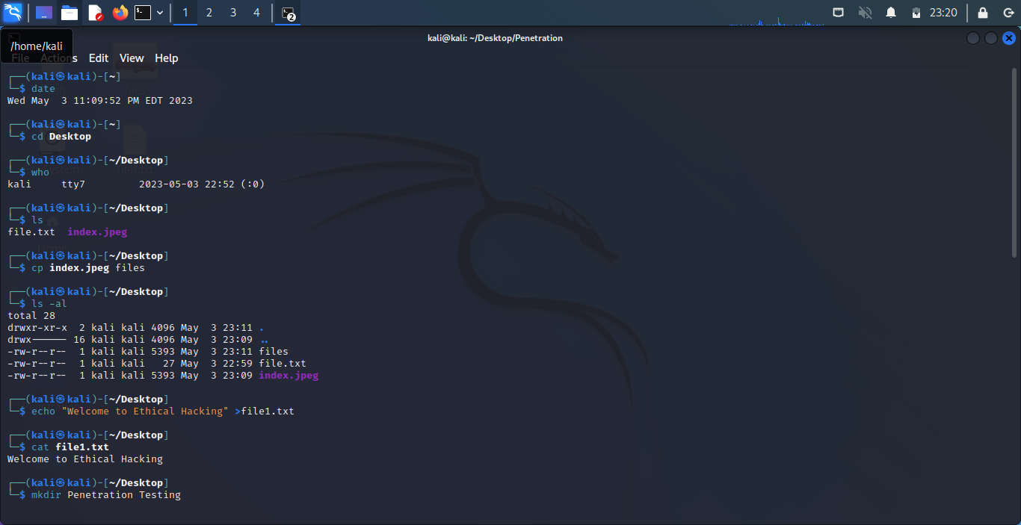**Output :**

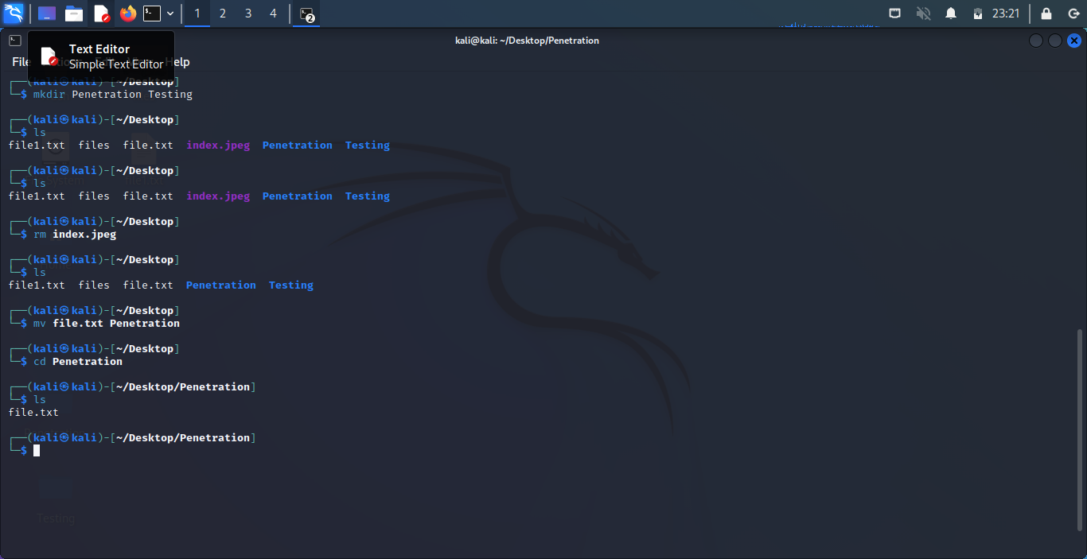

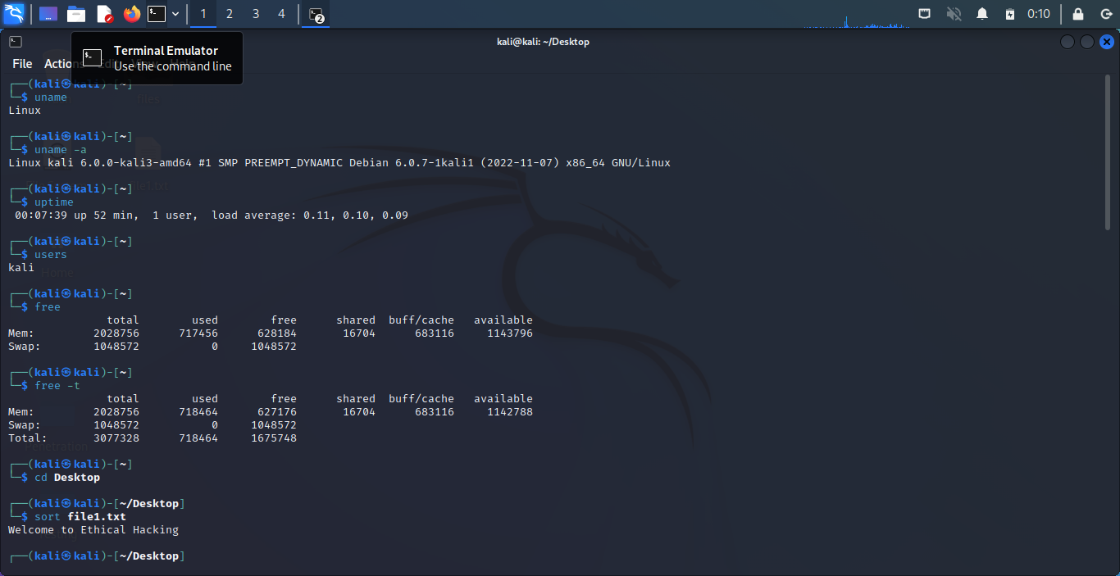

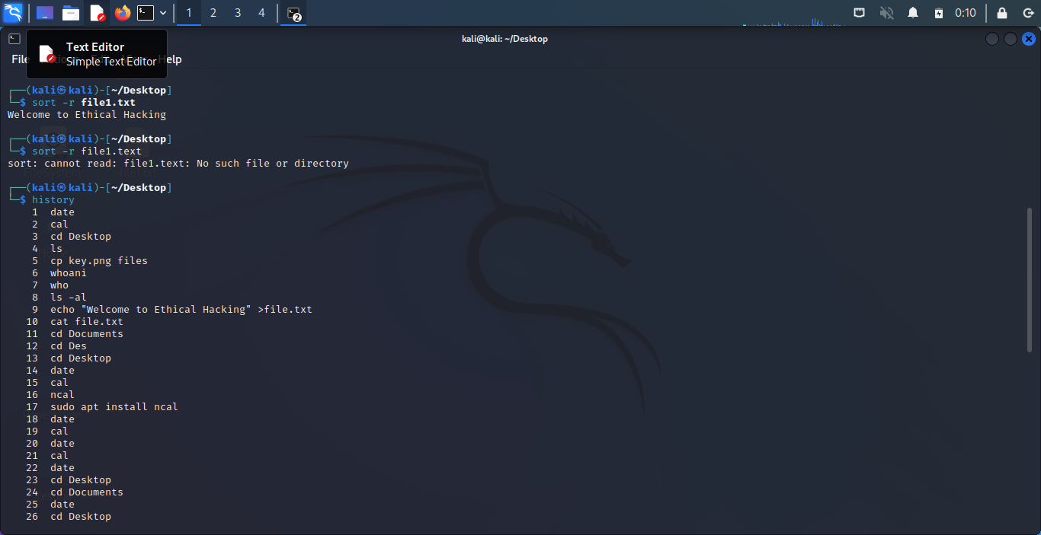

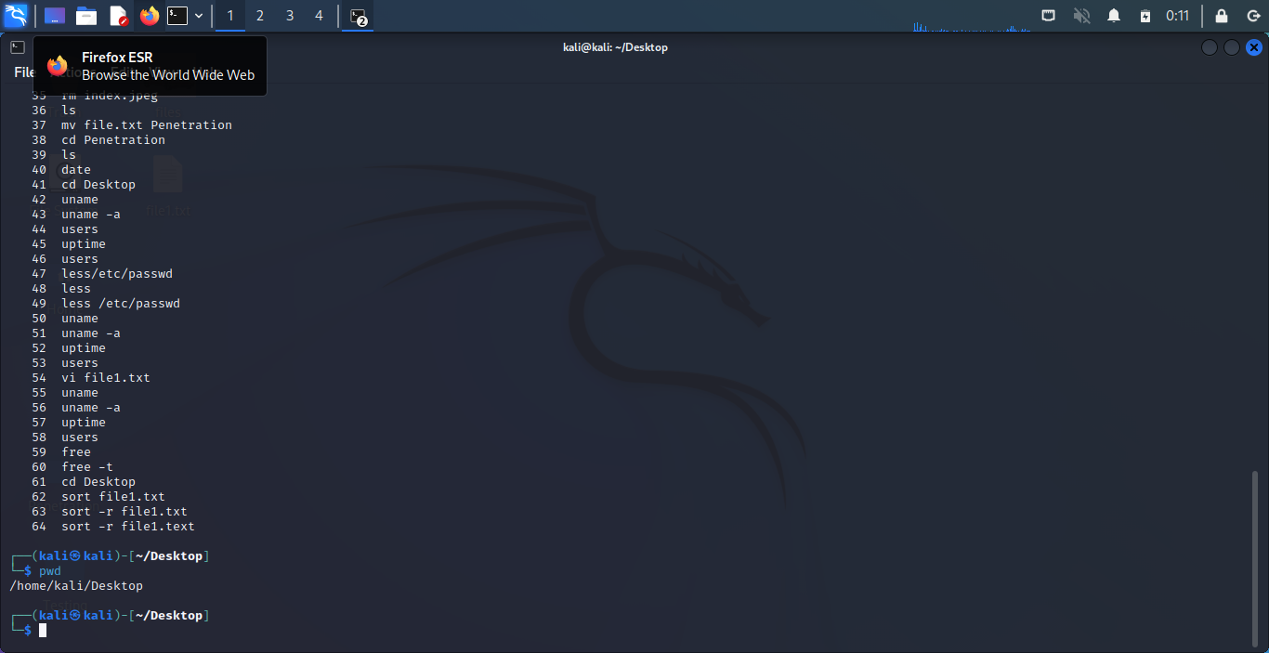

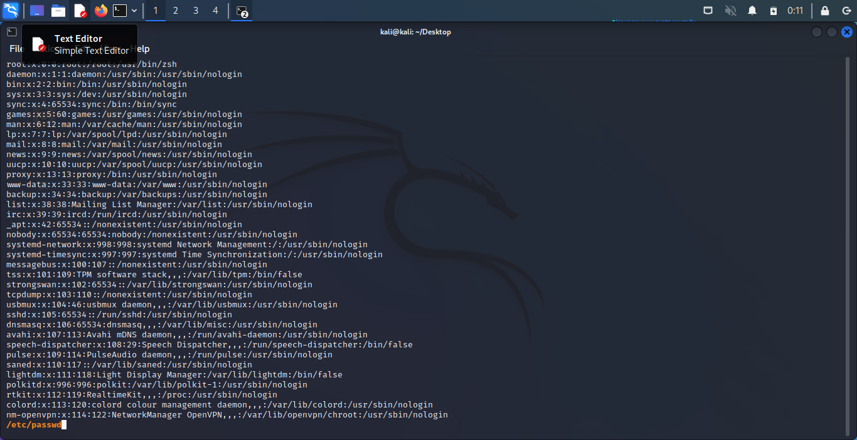

Less Command

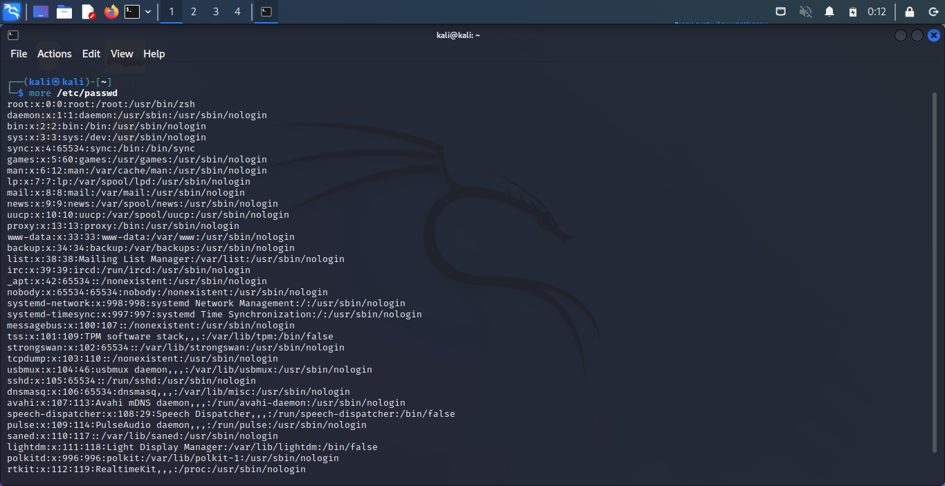

Vi Command

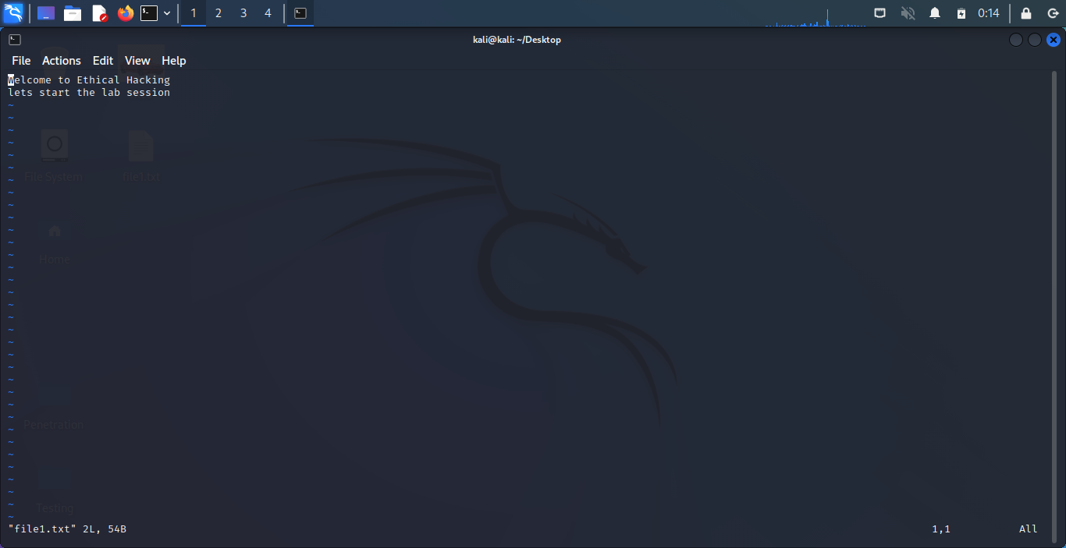

**Result :**

Hence all the basic commands of kali Linux is Executed.